

Tools to support organization for the

**APRIL 9th**

INFORMATION SHARING MEETING

ORGANIZING INFORMATION COLLECTION



STEP ONE

**COORDINATE COMPLETING THE FORMS WITH GRADE 7 TEACHERS IN YOUR SCHOOL.**

District staff involved with students (counsellors, AbEd, CCWs, Helping Teachers, physiotherapists, OTs, and SLPs **will contact you** about students they have worked with and:

* Pass on notes that need to be shared with secondary schools
* Indicate interest in attending a meeting to collaborate on transition supports



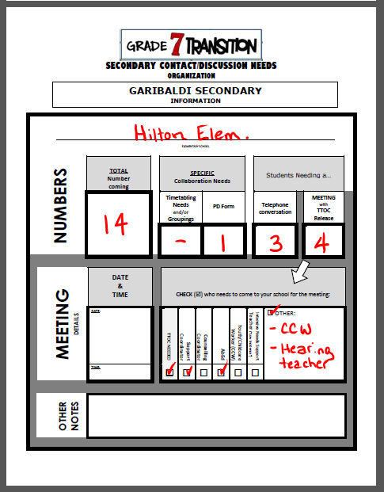STEP TWO

**ORGANIZE NOTES**

**FOR EACH HIGH SCHOOL**

ONLY this part needs to be completed…the rest can be done together on APRIL 9th



STEP THREE

**ORGANIZE NOTES**

If there are timetabling or grouping notes …complete that **separately** from the Transition Form.

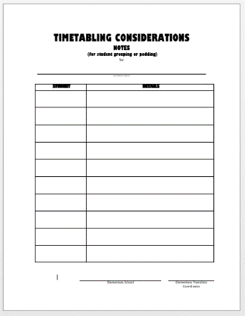

**OPTIONAL**

**TOOL**



**PILE**

**2**

**Student information to DISCUSS**

STEP FOUR

**ORGANIZE NOTES INTO TWO PILES**

**FOR EACH SCHOOL**

**2**

**1**

**PILE**

**PILE**



**Student information to DISCUSS**

**Student information to pass on for reference at the school.**



STEP FIVE

**COMPLETE A PD FORM FOR EACH STUDENT NEEDING EA TIME AT SECONDARY.**

You will bring these to the APRIL MEETING.

**PLEASE DO NOT SUBMIT THE FORMS**

Secondary LEARNING SUPPORT DEPARTMENT HEADS will submit the PD Forms to Learning Services **by APRIL 12th**.

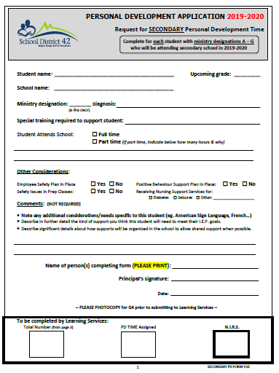

**USE the**

**SECONDARY PD FORM**